COMMENTS FROM GUESTS

The kindness you displayed has shown us a picture of the kindness of our Savior. We have seen Jesus with skin on displayed through you all.

You’ve provided a beautiful refuge here surrounded by God’s wonderful creation. May He bless you with joy in knowing you’ve served in His name and it has made a difference.

The Lord has used you to bless, to free, to nudge, and I leave with more peace, more energy, more faith even than when I arrived.
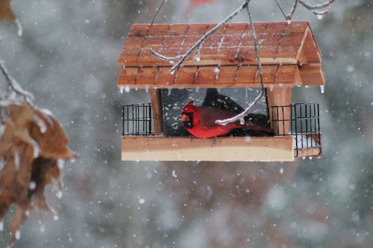

The Broom Tree Refuge is one of those places where the Lord is working. God has used you to create a very special place. We came away refreshed and recharged for work and ministry after our stay at Broom Tree.

For us The Broom Tree has been a place
of fun and fellowship:
- quiet and contemplation
- freedom to “be” as well as “do”
- wonderful enjoyment, laughter and refreshment
- time to re-group, re-think, re-dedicate, and relax
- acceptance, where someone listens, comforts, encourages, and makes us feel special and loved
- the spirit of God’s unconditional love and grace given freely—and given with joy.

COSTS
We recognize that those in ministry are often not well supported financially. The Broom Tree Refuge is operated on a donation basis according to what guests can afford to contribute toward the cost of their stay. Tax deductible gifts from churches and individuals are gratefully accepted and subsidize the operations of TBTR.
FOR ADDITIONAL INFORMATION
To schedule a visit; to become involved in the ministry through volunteer help, prayer or financial support contact us at:

Address: The Broom Tree Refuge
4001 Sunny Fox Rd.
Mountain View, AR 72560

Email: tbtr@thebroomtreerefuge.org Website: www.thebroomtreerefuge.org
Telephone: 870-591-6204 or 870-591-6710

The Broom Tree Refuge is a non-profit, 501(c)(3) corporation. Your financial gifts are very much appreciated and tax-deductible.

The Broom Tree Refuge
Ministering to Those in Ministry

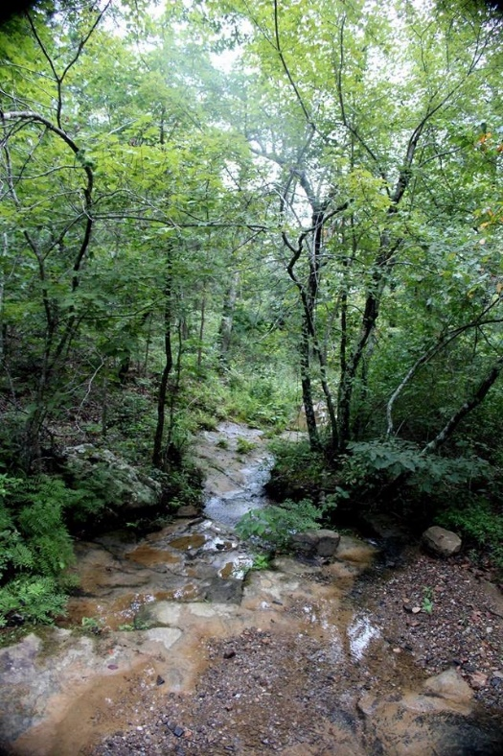
VISION

Our desire is to provide a place where we can come alongside and facilitate emotional, spiritual, physical and mental wholeness among those in Christian ministry.

Sometimes this means providing a place of refuge for those who are experiencing the day-to-day pressures of ministry. Just as the Lord took time away from ministry.

At other times the need goes deeper. As missionaries and pastors face crisis, burnout, transitions, conflicts, political upheaval, disillusionment, and loss of vision, we see ministry fatalities becoming a common occurrence. The very nature of the role of those in ministry mean that their own needs are often overlooked and neglected – by themselves and others. The Broom Tree Refuge exists to facilitate healing and restoration so they can return to or continue in effective ministry.

SERVICES

We provide a variety of services for guests, including:
- A place of physical and spiritual retreat for reflection, renewal and healing for individuals, families and small groups.
- Career assessment and counseling for ministry preparation or role transition.
- Biblically grounded, solution focused, counseling.
- Life or ministry transition counseling.
- Solitude for writing.

STAFF
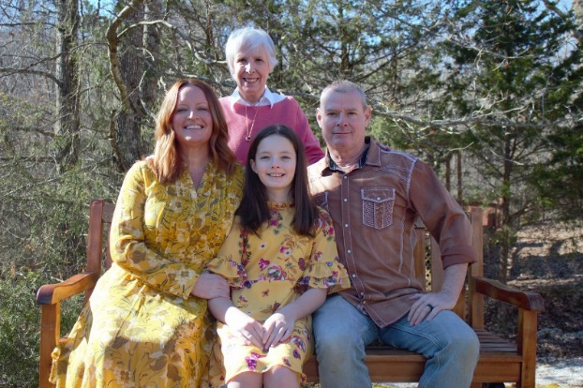

Sandi, Adam & Lanie Ray -Stewards of The Broom Tree Refuge

Sandi, Adam and Lanie are stewards and caregivers at The Broom Tree Refuge. Sandi was with Wycliffe Bible Translators for 27 years. She originally worked with the Australian Aborigines. Later, she was an International Teaming Consultant, counselor and career counselor. Sandi brings her gifts and years of mission experience to this ministry.

Adam, Lanie, and Michah Ray moved to Mountain View in 2012. They have become a significant part of the team here at TBTR. Adam is working full time and Lanie part time. They bring a combination of gifts and experience that allow them to make a critical contribution at TBTR. Adam grew up on the mission field and understands many of the situations and stresses people work under. In addition, he is a skilled handyman for which there is a constant need. Lanie has a heart for coming along side and helping people. She also has wonderful office/computer skills which is also a constant need. They both love interacting with people, which is a big part of the ministry here are The Broom Tree Refuge.

LOCATION
The Broom Tree Refuge is nestled on 40 acres in the beautiful Ozarks of north central Arkansas. It is located about 100 miles north of the Little Rock National Airport (LIT). The Refuge itself is 12 miles south from the city of Mountain View, off State Route 9.

Mountain View is a delightful community known for its music and locally produced crafts. The nearby Ozark Folk Center, which is an Arkansas State Park, provides glimpses into how life was lived in the early days in the Ozarks. There are several rivers and lakes as well as caverns in the area, providing opportunity for boating, fishing, hiking and just enjoying nature.

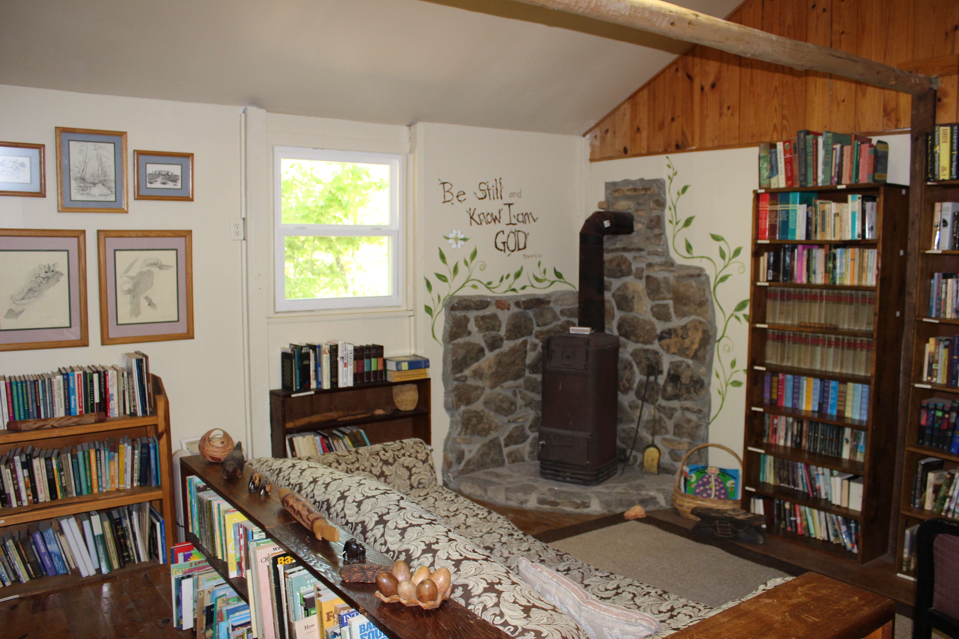

The rustic library, a quiet place

ACCOMMODATIONS

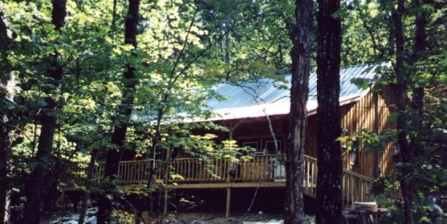
Guests at The Broom Tree Refuge will stay in one of two cabins on the property. All household needs, including linens and food are provided. All guests need bring are personal items. Food restrictions and preferences are addressed when accommodations are booked.
The three-bedroom cabin

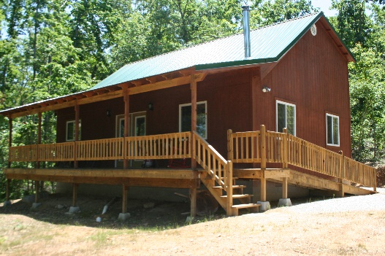
The one-bedroom cabin

